**Target Business Case Study**

**Context:**

Target is a globally renowned brand and a prominent retailer in the United States. Target makes itself a preferred shopping destination by offering outstanding value, inspiration, innovation and an exceptional guest experience that no other retailer can deliver.

This particular business case focuses on the operations of Target in Brazil and provides insightful information about 100,000 orders placed between 2016 and 2018. The dataset offers a comprehensive view of various dimensions including the order status, price, payment and freight performance, customer location, product attributes, and customer reviews.

By analyzing this extensive dataset, it becomes possible to gain valuable insights into Target’s operations in Brazil. The information can shed light on various aspects of the business, such as order processing, pricing strategies, payment and shipping efficiency, customer demographics, product characteristics, and customer satisfaction levels.

**_______________________________________**

**Dataset**: <https://drive.google.com/drive/folders/1TGEc66YKbD443nslRi1bWgVd238gJCnb>

The data is available in 8 csv files:

1. customers.csv
2. sellers.csv
3. order_items.csv
4. geolocation.csv
5. payments.csv
6. reviews.csv
7. orders.csv
8. products.csv

**__________________________________**_____

The column description for these csv files is given below.

The **customers.csv** contain following features:

|  |  |
| --- | --- |
| **Features** | **Description** |
| customer_id | ID of the consumer who made the purchase |
| customer_unique_id | Unique ID of the consumer |
| customer_zip_code_prefix | Zip Code of consumer’s location |
| customer_city | Name of the City from where order is made |
| customer_state | State Code from where order is made (Eg. são paulo - SP) |

The **sellers.csv** contains following features:

|  |  |
| --- | --- |
| **Features** | **Description** |
| seller_id | Unique ID of the seller registered |
| seller_zip_code_prefix | Zip Code of the seller’s location |
| seller_city | Name of the City of the seller |
| seller_state | State Code (Eg. são paulo - SP) |

The **order_items.csv** contain following features:

|  |  |
| --- | --- |
| **Features** | **Description** |
| order_id | A Unique ID of order made by the consumers |
| order_item_id | A Unique ID given to each item ordered in the order |
| product_id | A Unique ID given to each product available on the site |
| seller_id | Unique ID of the seller registered in Target |
| shipping_limit_date | The date before which the ordered product must be shipped |
| price | Actual price of the products ordered |
| freight_value | Price rate at which a product is delivered from one point to another |

The **geolocations.csv** contain following features:

|  |  |
| --- | --- |
| **Features** | **Description** |
| geolocation_zip_code_prefix | First 5 digits of Zip Code |
| geolocation_lat | Latitude |
| geolocation_lng | Longitude |
| geolocation_city | City |
| geolocation_state | State |

The **payments.csv** contain following features:

|  |  |
| --- | --- |
| **Features** | **Description** |
| order_id | A Unique ID of order made by the consumers |
| payment_sequential | Sequences of the payments made in case of EMI |
| payment_type | Mode of payment used (Eg. Credit Card) |
| payment_installments | Number of installments in case of EMI purchase |
| payment_value | Total amount paid for the purchase order |

The **orders.csv** contain following features:

|  |  |
| --- | --- |
| **Features** | **Description** |
| order_id | A Unique ID of order made by the consumers |
| customer_id | ID of the consumer who made the purchase |
| order_status | Status of the order made i.e. delivered, shipped, etc. |
| order_purchase_timestamp | Timestamp of the purchase |
| order_delivered_carrier_date | Delivery date at which carrier made the delivery |
| order_delivered_customer_date | Date at which customer got the product |
| order_estimated_delivery_date | Estimated delivery date of the products |

The **reviews.csv** contain following features:

|  |  |
| --- | --- |
| **Features** | **Description** |
| review_id | ID of the review given on the product ordered by the order id |
| order_id | A Unique ID of order made by the consumers |
| review_score | Review score given by the customer for each order on a scale of 1-5 |
| review_comment_title | Title of the review |
| review_comment_message | Review comments posted by the consumer for each order |
| review_creation_date | Timestamp of the review when it is created |
| review_answer_timestamp | Timestamp of the review answered |

The **products.csv** contain following features:

|  |  |
| --- | --- |
| **Features** | **Description** |
| product_id | A Unique identifier for the proposed project. |
| product_category_name | Name of the product category |
| product_name_lenght | Length of the string which specifies the name given to the products ordered |
| product_description_lenght | Length of the description written for each product ordered on the site |
| product_photos_qty | Number of photos of each product ordered available on the shopping portal |
| product_weight_g | Weight of the products ordered in grams |
| product_length_cm | Length of the products ordered in centimeters |
| product_height_cm | Height of the products ordered in centimeters |
| product_width_cm | Width of the product ordered in centimeters |

**_______________________________________**

**Dataset schema:**

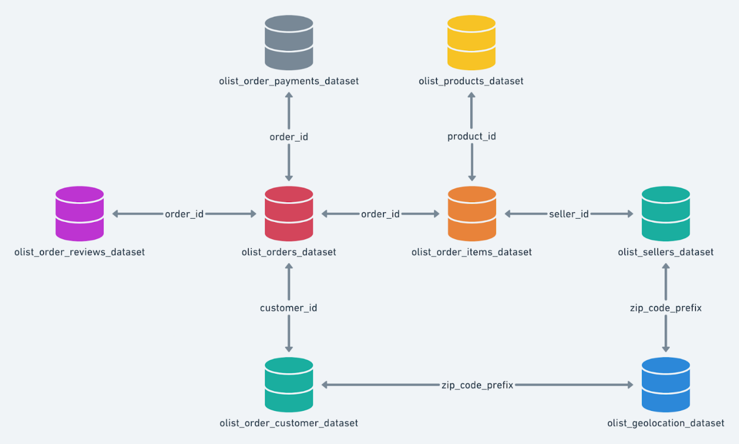

**_______________________________________**

**Problem Statement:**

Assuming you are a data analyst/ scientist at Target, you have been assigned the task of analyzing the given dataset to extract valuable insights and provide actionable recommendations.

**What does ‘good’ look like?**

1. **Import the dataset and do usual exploratory analysis steps like checking the structure & characteristics of the dataset:**
   1. Data type of all columns in the "customers" table.
   2. Get the time range between which the orders were placed.
   3. Count the Cities & States of customers who ordered during the given period.
2. **In-depth Exploration:**  
   1. Is there a growing trend in the no. of orders placed over the past years?
   2. Can we see some kind of monthly seasonality in terms of the no. of orders being placed?
   3. During what time of the day, do the Brazilian customers mostly place their orders? (Dawn, Morning, Afternoon or Night)
      * 0-6 hrs : Dawn
      * 7-12 hrs : Mornings
      * 13-18 hrs : Afternoon
      * 19-23 hrs : Night
3. **Evolution of E-commerce orders in the Brazil region:**
   1. Get the month on month no. of orders placed in each state.
   2. How are the customers distributed across all the states?
4. **Impact on Economy: Analyze the money movement by e-commerce by looking at order prices, freight and others.**
   1. Get the % increase in the cost of orders from year 2017 to 2018 (include months between Jan to Aug only).  
      You can use the "payment_value" column in the payments table to get the cost of orders.
   2. Calculate the Total & Average value of order price for each state.
   3. Calculate the Total & Average value of order freight for each state.
5. **Analysis based on sales, freight and delivery time.**
   1. Find the no. of days taken to deliver each order from the order’s purchase date as delivery time.  
      Also, calculate the difference (in days) between the estimated & actual delivery date of an order.  
      Do this in a single query.  
        
      You can calculate the delivery time and the difference between the estimated & actual delivery date using the given formula:
      * **time_to_deliver** = order_delivered_customer_date - order_purchase_timestamp
      * **diff_estimated_delivery** = order_delivered_customer_date - order_estimated_delivery_date
   2. Find out the top 5 states with the highest & lowest average freight value.
   3. Find out the top 5 states with the highest & lowest average delivery time.
   4. Find out the top 5 states where the order delivery is really fast as compared to the estimated date of delivery.  
      You can use the difference between the averages of actual & estimated delivery date to figure out how fast the delivery was for each state.
6. **Analysis based on the payments:**
   1. Find the month on month no. of orders placed using different payment types.
   2. Find the no. of orders placed on the basis of the payment installments that have been paid.

**_______________________________________**

**Evaluation Criteria (100 points):**

1. Initial exploration like checking the structure & characteristics of the data (15 points)
2. In-depth Exploration (15 points)
3. Evolution of E-commerce orders in the Brazil region  (10 points)
4. Impact on Economy (20 points)
5. Analysis on sales, freight and delivery time (20 points)
6. Analysis based on the payments (10 points)
7. Actionable Insights & Recommendations (10 points)

**_______________________________________**

**Submission Process <IMP>:**

Once you’re done with the case study…

* Use a Word document to paste your SQL queries along with a screenshot of the first 10 rows from the output.
* List down any valuable insights that you find during the analysis and provide some action items from the company’s perspective in order to improve the current situation.
* Convert your solutions doc into a PDF, and upload the same on the platform.
* Please note that after submitting once, you will not be allowed to edit your submission.

**_______________________________________**

**General Guidelines:**

* Evaluation will be kept lenient, so make sure you attempt this case study.
* Try to attempt this before it is discussed in the Live Case Discussion with the Instructor.
* It is understandable that you might struggle with getting started on this or feel stuck at some point.  
  In such case:
  + Read the question carefully and try to understand what exactly is being asked.
  + Brainstorm a little. If you’re getting an error, remember that Google is your best friend.
  + You can watch the lecture recordings or go through your lecture notes once again if you feel like you’re getting confused over some specific topics.
  + Discuss your problems with your peers. Make use of the Slack channel and WhatsApp group.
  + Only if you think that there’s a major issue, you can reach out to your Instructor via Slack or Email.